LABORATORY EXERCISE 3

ADVANCED TABLE DESIGN, RELATIONSHIPS & USER MANAGEMENT

Learning Objectives
By the end of this laboratory exercise, students should be able to:
- To move beyond simple single-table databases and accurately model real-world data connections and user roles by practically implementing One-to-Many and Many-to-Many relationships within an SQL database.
- To understand and utilize the FOREIGN KEY constraint as a fundamental mechanism to prevent orphaned records and ensure that relationships between tables remain consistent and valid.
- To design a database schema that supports a multi-role application (Admin, Teacher, Student) with secure login functionality.
- To reinforce data quality and business logic through the use of UNIQUE and NOT NULL constraints, ensuring the accuracy and reliability of the stored information.

Prerequisite student experiences and knowledge
Students are expected to have a foundational understanding of the following concepts:
- Primary Keys
  - The purpose of a unique identifier for each record in a table is to ensure that it is unique.
- Foreign Keys
  - A field in one table that uniquely identifies a row in another table, establishing a link between them.
- Cardinality in ER Diagrams
  - The ability to interpret and draw Entity-Relationship Diagrams, explicitly recognizing the symbols and notation for one-to-many (1:M) and many-to-many (M:N) relationships.
- Basic VB.NET Windows Forms development is needed to create the user interface.

Background
This lab focuses on translating conceptual relationships into a physical database schema that supports a multi-user academic system. The Foreign Key (FK) constraint is the primary tool that enforces referential integrity. We create a junction table (or associative entity) to resolve a many-to-many relationship. Furthermore, we will implement a user authentication system where access and functionality are determined by roles (Admin, Teacher, Student).

Materials/Resources
- dbGate
- Personal Computer with Internet Access
- XAMPP/WAMP/LAMP server installed
- Visual Studio(VB.Net Development)
Laboratory Activity
Using your DB_Lastname database, perform the following steps.
- Create the Users and Roles Tables (Foundation for Login)
  - The tables will manage user authentication and authorization.
  - The roles tables defines the possible roles
    - 1: Admin
    - 2: Teacher
    - 3: Student
  - the users table stores login credentials and links each user to a role. The username must be unique.
    - Roles Table schema:
- role_id (INT, PK, AI)
- role_name (VARCHAR(50), UNIQUE, NOT NULL) (e.g., 'Admin', 'Teacher', 'Student')
    - Users Table Schema:
      - user_id (INT, PK, AI)
      - username (VARCHAR(255), UNIQUE, NOT NULL)
      - password_hash (VARCHAR(255), NOT NULL)
        - Stored hashed password, never plain text
      - role_id (INT, FK to Roles(role_id), NOT NULL)
- Create the Instructors and Students Tables (Link to Users)
  - These tables store profile information. They have a one-to-one relationship with the Users table for accounts with the corresponding role.
  - The user_id is a foreign key that also has a UNIQUE constraint to enforce the one-to-one relationship.
    - Instructors Table Schema:
      - instructor_id (INT, PK, AI)
      - user_id (INT, FK to Users(user_id), UNIQUE, NOT NULL) *// Links to their login account*
      - first_name (VARCHAR(100), NOT NULL)
      - last_name (VARCHAR(100), NOT NULL)
      - department (VARCHAR(100))
    - Students Table Schema:
      - student_id (INT, PK, AI)
      - user_id (INT, FK to Users(user_id), UNIQUE, NOT NULL) *// Links to their login account*
      - first_name (VARCHAR(100), NOT NULL)
      - last_name (VARCHAR(100), NOT NULL)
      - date_of_birth (DATE)

- Create the Courses Table
  - This table stores course information. It has a foreign key to the Instructors table, establishing that one Instructor can teach Many Courses
    - Courses Table Schema:
      - course_id (INT, PK, AI)
      - course_code (VARCHAR(50), UNIQUE, NOT NULL) (e.g., 'CS101')
      - course_name (VARCHAR(255), NOT NULL)
      - instructor_id (INT, FK to Instructors(instructor_id))
        - Can be NULL if unassigned
- Create the Enrollments Junction Table
- This table resolves the Many-to-Many relationship between Students and Courses. Its composite primary key ensures a student cannot be enrolled in the same course more than once.
  - Enrollments Table Schema:
    - enrollment_id (INT, PK, AI)
      - Optional surrogate key, often easier for ORMs
    - student_id (INT, FK to Students(student_id), NOT NULL)
    - course_id (INT, FK to Courses(course_id), NOT NULL)
    - enrollment_date (DATETIME, NOT NULL, DEFAULT CURRENT_TIMESTAMP)
    - CONSTRAINT unique_enrollment UNIQUE (student_id, course_id)
      - Essential business rule
- VB.NET Application Implementation Tasks:
  - Create Login Form
    - Build a VB.NET Windows Form with textboxes for username and password.
    - Click and query the user's table using the login button to find the username.
    - Compare the hashed input password with the stored password_hash.
    - On successful login, check the role_id and redirect the user to the appropriate form (e.g., AdminForm, TeacherForm, StudentForm), passing the user's ID and role.
  - Create an Admin management form.
    - This form should only be accessible to users with the 'Admin' role.
    - Functionality:
      - Add Instructors/Teachers:
        - This is a two-step process:
- Create User Account: First, add a new record to the Users table with a role of 'Teacher' (role_id 2).
- Create Instructor Profile: Then, add a corresponding record to the Instructors table, using the user_id from the first step.
    - View lists of all users, instructors, and students.
    - Reset user passwords (implementing a secure method).

Output / Results
- Screenshot of Complete Database Schema:
  - Show all tables: Users, Roles, Instructors, Students, Courses, Enrollments.
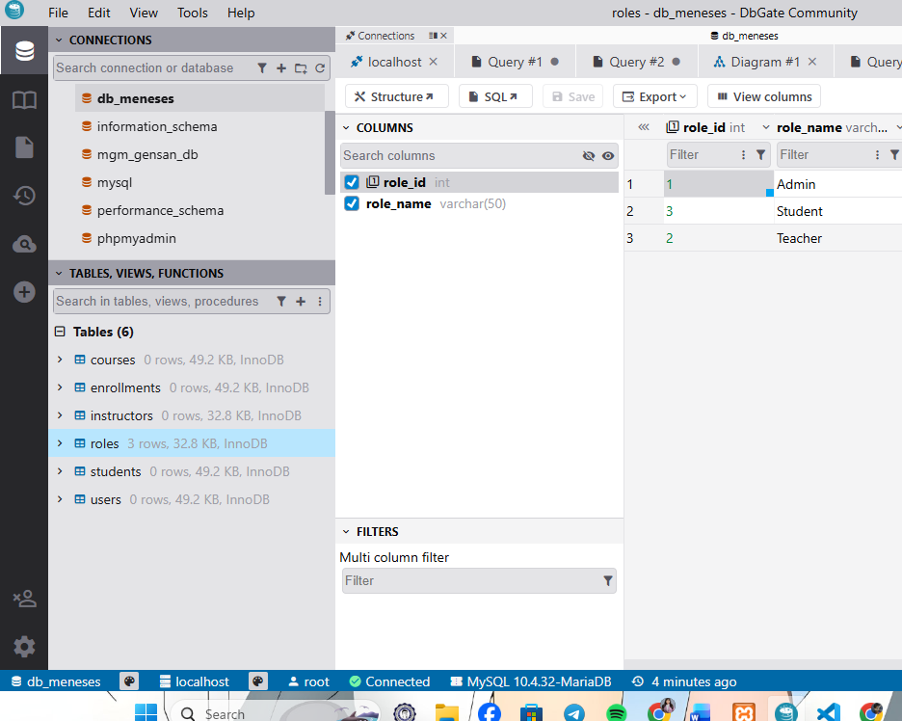
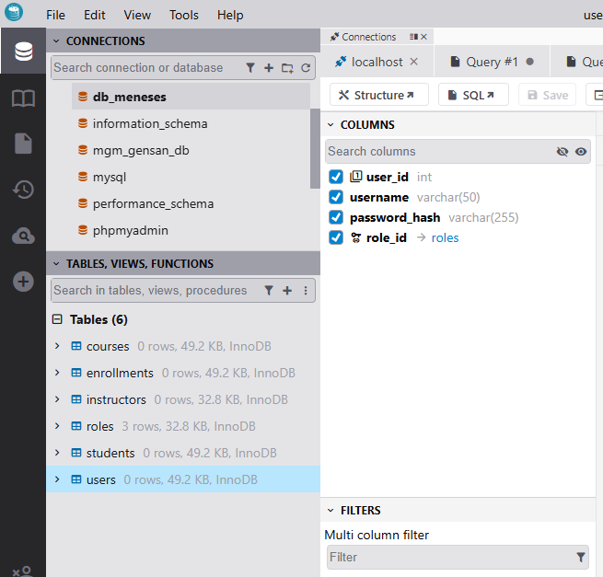
  - The Foreign Keys tab for each table should clearly show all constraints.
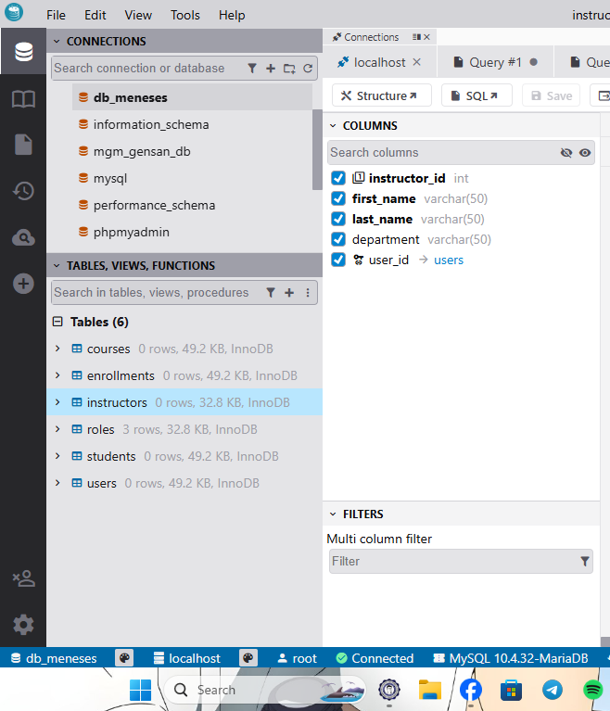

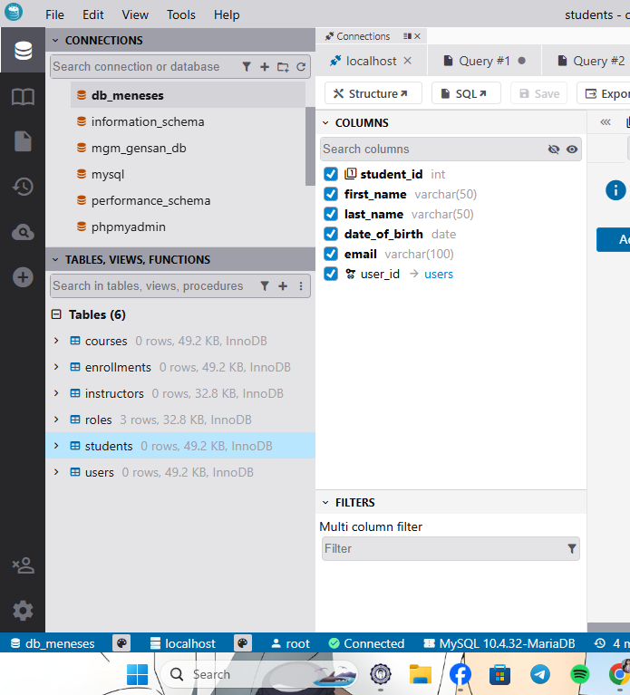

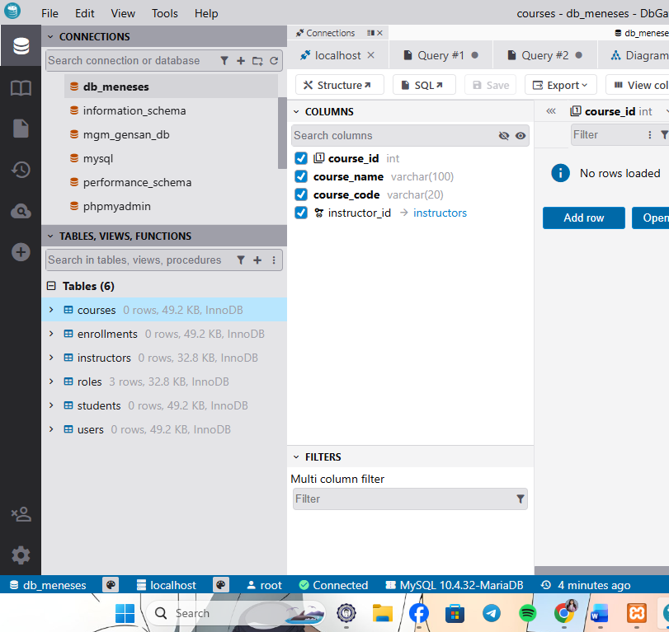

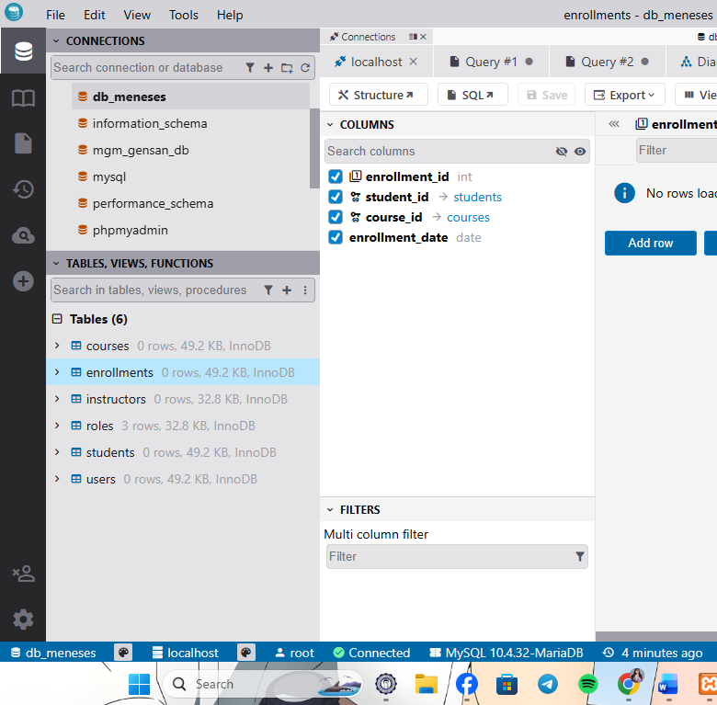

- Screenshot of Database EER Diagram:
  - A visual diagram showing all tables with connecting lines illustrating the relationships. This should clearly show:
    - Users -> Roles (Many-to-One)
    - Users -> Instructors (One-to-One)
    - Users -> Students (One-to-One)
    - Instructors -> Courses (One-to-Many)
    - Students -> Enrollments (One-to-Many)
    - Courses -> Enrollments (One-to-Many)

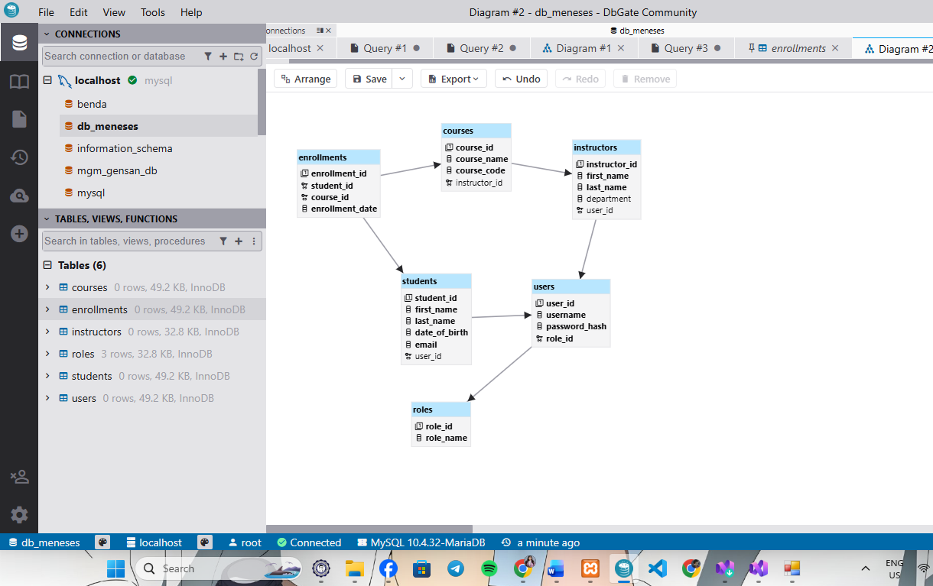

- Screenshots of VB.NET Application:
    - Login form.
    - The admin form shows the interface for adding a new instructor (both user account and profile details).

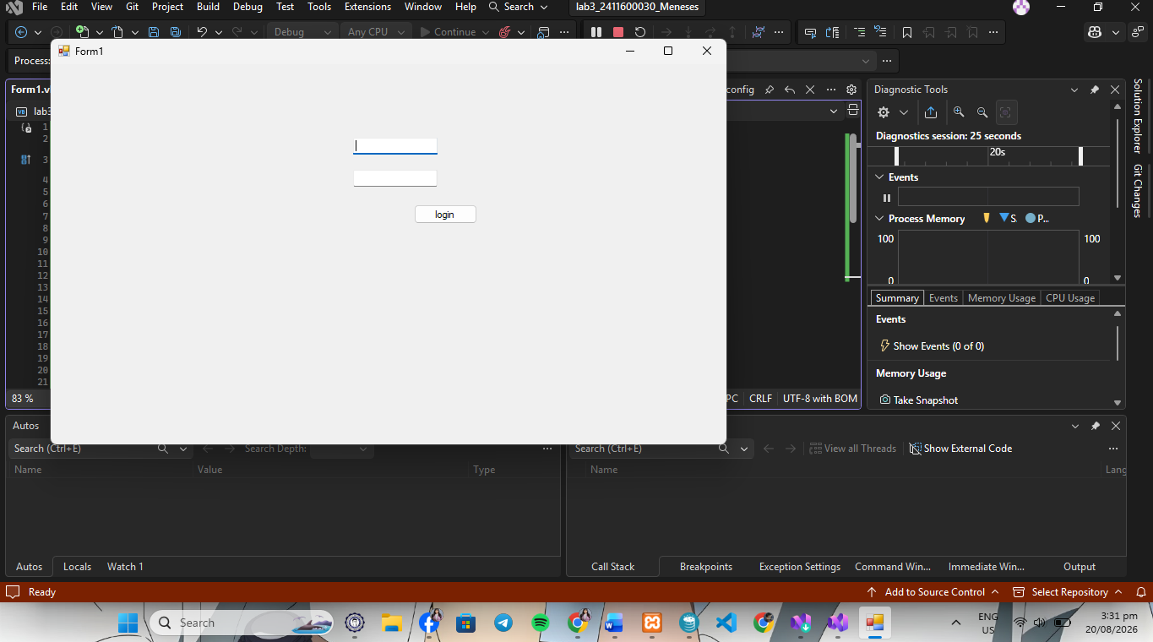

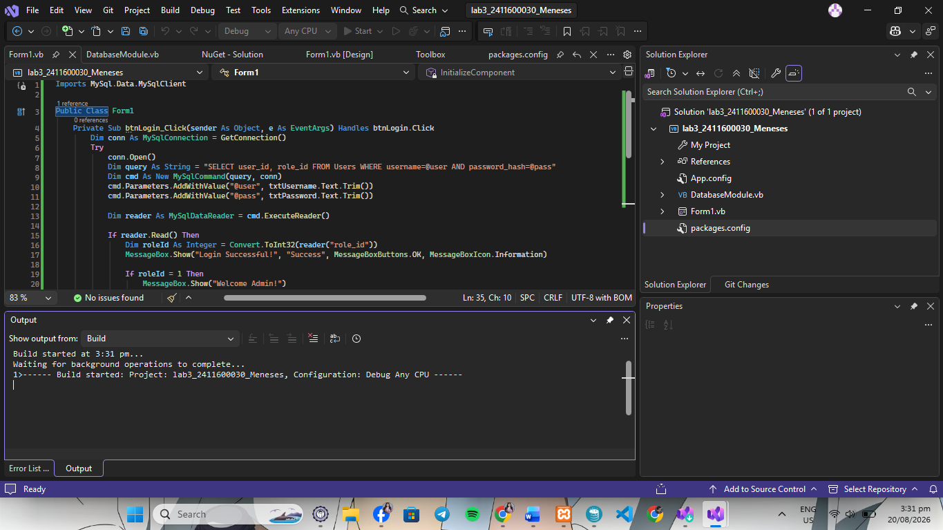

QUESTIONS:
- What does the FOREIGN KEY constraint on the instructor_id column in the Courses table prevent?
It prevents inserting a course with an instructor_id that does not exist in the Instructors table, and it stops you from deleting an instructor who is actively assigned to existing courses. This ensures referential integrity across your database.
- How does the UNIQUE constraint on the user_id field in the Instructors table enforce business logic?
It guarantees a strict 1-to-1 relationship between a user account and an instructor profile. This prevents duplicate teacher profiles from linking to the exact same login account in the Users table.
- Describe the process an Admin would use to add a new Teacher to the system in your VB.NET application.
• User Account Creation: The Admin inserts a new record into the Users table with a new username, password_hash, and sets the role_id to 2 (Teacher).
• Database Auto-ID Generation: MySQL auto-generates a unique user_id for that new account.
• Instructor Profile Creation: The system retrieves that generated user_id and inserts a new entry into the Instructors table containing the teacher's profile details (first_name, last_name, email), binding it to the generated user_id.
• Course Assignment: Once created, the new teacher's instructor_id can be linked to rows in the Courses table.

Conclusion
In this lab activity, a multi-user academic system was successfully integrated using VB.NET Windows Forms and a MySQL database. Implementing database constraints—such as Foreign Keys for referential integrity and Unique keys for 1-to-1 mapping—ensured strict data validity and reliable role-based relationships. The final application effectively handles secure authentication, properly routing users based on their administrative permissions while trapping invalid login attempts.

